Body Shaming and its Psychological Consequences:
A Comprehensive Analysis

Aryan Sood | Shruti Pathak | Dipanshu Chaudhary
Aryan Sood | Bennett University | Bennett University
Bennett University | Bennett University | Bennett University
Bennett University | Greater Noida, Uttar Pradesh | Greater Noida, Uttar Pradesh
Greater Noida, Uttar Pradesh | Greater Noida, Uttar Pradesh | Greater Noida, Uttar Pradesh
Greater Noida, Uttar Pradesh | shrutipathak144@gmail.com | dipanshu9719147388@gmail.com
aryansood38@gmail.com | shrutipathak144@gmail.com | dipanshu9719147388@gmail.com
aryansood38@gmail.com | Yogesh Pal
Shreyanshi | Yogesh Pal
Bennett University | SCSET
Greater Noida, Uttar Pradesh | Bennett University(Times of India
mukeshshreyanshi@gmail.com | Group)
 | Greater Noida
 | er.yogeshpal15@gmail.com

Abstract— In this comprehensive meta-analysis, the study delves into the widespread issue of body shaming, revealing its pervasive impact on various aspects of human life and its profound implications for mental health. The paper first explores the origins of body shaming, including societal norms, media influences, and interpersonal dynamics. It highlights the various forms it takes and its detrimental effects on self-esteem, body image, and psychological well-being. Particularly among adolescents and teenagers in today's social media-driven world, the pressure to conform to idealized beauty standards is significant, leading to negative consequences for their development and health. The research emphasizes the long-lasting mental health effects of body shaming, including depression, body dysmorphia, low self-esteem, and eating disorders. The study also discusses the emergence of Body Positivity movements as a means to challenge societal norms and promote inclusivity and empathy. Furthermore, the research addresses body shaming in the workplace and presents strategies to combat it, stressing the importance of awareness campaigns, education, and policy changes. In conclusion, the study underscores the critical need for a culture of acceptance and support, the promotion of positive body image, and efforts to mitigate the severe mental health toll that body shaming takes on individuals and communities.

Overall, this research provides a comprehensive overview of body shaming, its root causes, and its far-reaching impacts on mental health and well-being. It highlights the urgency of addressing this issue in various contexts, from adolescence to the workplace, and offers solutions, such as awareness campaigns and societal changes, to foster a more inclusive and empathetic future.
Keywords— Body shaming, Mental health, Age, Gender, Societal norms, Appearance-based discrimination, Cyberbullying, Self-esteem, Social-media, Depression, Acceptance

this paper is that an unhealthy person should be given treatment to improve their quality of life and remove the negativity from their surroundings to build a better life culture for everyone.[1]

A. History of Body Shaming in India

Body Shaming has been a worldwide issue that transcends all types of cultural boundaries, and India is no exception. Body shaming in India has been influenced continuously by various societal, cultural, and various historical factors. We must understand that the focus on body image and various beauty standards has escalated in recent times, it is also important to understand its historical point of view to analyse its evolution and impact on an individual.

1) Ancient India (2000 BCE-1200 CE)

In ancient India, the emphasis on Body Shaming was less given to an individual's body weight and more to other aspects. The “perfect body” of a person was identified by various external features like dark skin, which signified being closer to the earth and therefore more ethical. The carved bodies of various Hindu gods and goddesses acted as role models for many. Still, even in this era, society was inclined to discriminate based on appearances. However, people with any type of physical disability were often found dealing with various types of ostracization.

2) Medieval India (1200 CE-1759 CE)
I. INTRODUCTION

As said by Kamila Czepczor-Bernat et al (2022), this research paper focuses on the connection between negative emotions and body image and the influence it has on the life of a person. People tend to face embarrassment and fear when they face societal standards and understand that they have not toned their bodies accordingly. As a result of this shame and fear, depression starts coming into existence in the minds of an individual, and the feeling of being left out will follow. The major emphasis that we are trying to set in

The medieval period in India brought a major change in Indian society, and the idea of beauty evolved significantly. The influence of the Mughal Empire in the Indian sub-continent brought the idea of lighter skin as the more dominant and desirable trait. This period also led to the creation of a social hierarchy that focused on the appearance of an individual, where beauty was given the highest status in society. The practice of “sutak” further escalated the idea that certain body functions of a woman during childbirth,

death, or menstruation were considered impure and would influence daily activities and rituals.

3) Colonial Era (1759 CE-1947 CE)

British Colonialism made a significant impact on the mindset of an ideal body in India. The Victorian era standards of beauty, which gave more preference to pale skin, were inflicted on the Indian population. Various skin-lightening products, such as Fair & Lovely, became a boon in the market. Thus, creating a mindset that fair skin is directly proportional to success and beauty in the world. During this period, we created a significant tilt towards various types of body shaming based on skin color and body structure.

4) Post-Independence Era (1947 CE- 1990 CE)

After ending British rule and gaining independence, India continued to struggle against various colonial legacies, including various Eurocentric beauty standards. The Indian Entertainment industry at that time played a major role in eternalizing these ideas across the country. Actresses with lighter skin tones and Western features started to dominate the Indian entertainment industry, and they set the benchmark of beauty in the mindset of various individuals. This led to a serious obsession with fair skin and a skyrocketing sale of beauty and skin-lightening products.

5) The 21st Century

The 21st Century has seen body shaming in India take on a completely different magnitude. The emergence of social media and globalization has just made the situation worse. Western beauty standards still play a major role in influencing the country's population by creating a completely different idea of beauty and attractiveness in their mind. This is leading to a high rate of body dissatisfaction, diseases, and a thrust in eating disorders among teenagers.

- LITERATURE REVIEW

According to Tylka (2018), body image disruption, also known as negative body image, can manifest in various ways, including appearance displeasure, self-objectification, body shame, and internalization of advertising beauty standards. A cross-sectional investigation identified that the prevalence of negative body image among youngsters could reach 71%, especially among female and overweight respondents. In other studies, the prevalence of body dissatisfaction in developed countries ranges from 16% to 55% in boys and 35% to 81% in girls. (Finito et al., 2013; Lawler & Nixon, 2011, as cited in Moehlecke et al., 2020). Aziz (2017) stated that past studies have discovered the relationship between media exposure and negative body image. The new media, mainly social media such as Instagram, provides instant access to a wide range of idealized physical appearances, which leads to negative body image among users. Since the number of body image
dissatisfaction is relatively high, raising awareness about positive body image is essential.[2]

- Impact of Body Shaming on the age group of 15-25 years

Body Shaming tends to have a major and detrimental effect on any individual within the age group of 15-25 years, which surrounds adolescence and early adulthood. This period in the life of an individual is considered to be a critical period of personal development, self-discovery, and self-realization. The impact of body shaming during these times can have a significant impact.

1) Mental Health Implications

Teenagers and adolescents who are encountered with any type of body shaming tend to be at a higher risk of developing various mental health problems like depression, anxiety, etc. The constant urge of self-doubt to comply with societal beauty standards can lead to constant sadness and worry. It can also affect an individual's personal growth.

2) Eating Disorders

The mental pressure to attain your ideal figure can lead to a series of unhealthy eating habits, and shaggy eating patterns which ultimately lead to various disorders like anorexia nervosa, bulimia, or binge-eating disorders. If not treated properly, it can lead to severe health consequences.

3) Body Image Distortion

Teenagers and the young generation are generally vulnerable to developing a negative body image due to the various types of social pressures they face. They start to consider their body as unattractive or distorted, which can lead to feelings of embarrassment and shame. Social media tend to create a fake scenario or profile in the minds of adolescents which creates a sense of false image in their mindset. It ultimately leads to self-doubt and a lack of self-appreciation.

4) Peer Relationships

Body shaming is often continued through peer pressure, which can happen both online and in person. An individual or an adolescent might be pressured to follow a certain beauty standard to fit in and avoid ignorance in a crowd. Those who face body shaming tend to avoid social gatherings and relationships out of fear or awkwardness, leading to social anxiety and loneliness.

5) Impact on Academic and Career Aspirations
Body Shaming can have a detrimental effect on the concentration of an individual during his academic and non-academic performances. The distraction towards fear of body image may lead to a tilt in focus from studies, potentially impacting the grades of an individual. Sometimes lack of focus or self-confidence can obstruct an individual's professional growth. Discrimination based on appearance or cast can also occur in the workplace which can hinder their self-confidence.

6) Sexual and Romantic Relationships

The fear of rejection in any relationship based on appearance can also baffle an individual’s self-confidence during the development of any type of romantic relationship. In some cases, body shaming can lead to individuals accepting the scenario where they are involved in any type of abusive or toxic relationship because they start believing that they are not eligible for a healthy relationship.

7) Development of Coping Mechanisms

To tackle the constant distress of body shaming, many individuals start using unhealthy constraints like drugs, smoking, and alcohol. This can hurt their physical and emotional well-being. Body shaming behavior factor is a trigger for stress in students but if the student is able to control his mindset and is able to adapt to the environment or the problems, they experience will actually reduce the level of stress on these students.

8) Social Media and Digital Consequences

The extensive use of social media platforms can aggravate body shaming in an individual’s life. The constant exposure to glamorized images and Porsche lifestyles can lead to feelings of insecurity and substandardness. Cyberbullying has been the talk of the hour for a very long time. Teenagers who face body shaming through different social media platforms are more vulnerable to various mental and health diseases like depression, anxiety, and many more.

9) Identity Development

Teenage and adolescence are considered to be the age of identity creation and identification. During these years, an individual starts exploring more about himself and his body. Body Shaming at this stage can leave a long-term scar on the mental state of an individual. It can also influence various future decisions and goals which can hinder the growth of an individual in his desirable stream.

10) Health Consequences
The emotional distress body shaming can put on an individual can be an alarming factor for various health issues like weak immune systems, digestive problems, and even stress-related issues. High school students who are overweight are more likely to suffer from depression and suicidal thoughts than their normal-weight peers, according to research from the Center for Advancing Health.

- INSIGHTS

Body Shaming has been a pervasive issue across the globe, which affects individuals from all age groups, genders, and cultural backgrounds. Our study showed that 100% of the population was aware of the concept of body shaming and 68% of the population has been body shamed based on color, height, weight, and sex at some stage of their life which could have led to mental health issues, depression or lack of self-confidence in an individual.
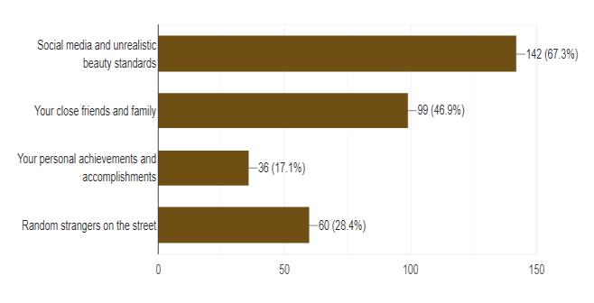

With the help of our survey, it was observed that 67.3% of the population believes that social media and unrealistic beauty standards are the root cause of Body Shaming. These platforms tend to publicize curated, apotheosize pictures, thereby creating a sense of insecurity among the crowd who don’t conform. These unrealistic standards lead to the extensiveness of body shaming, hurting the confidence and mental health of an individual.
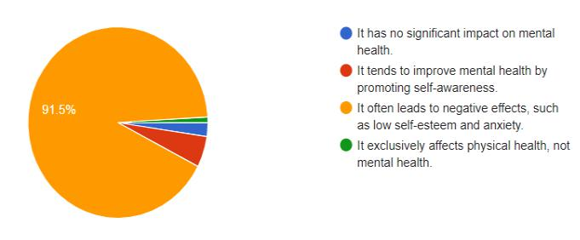

Body Shaming can have a major impact on the mental health of an individual during their early or formative years. During this stage of their life, it is important to understand that adolescents are very vulnerable to all types of negative
or positive comments. Sometimes, these issues can affect their future relationships and overall well-being. It can also lead to depression, eating disorders, anxiety, and profound psychological trauma during the crucial refining stages of their life.
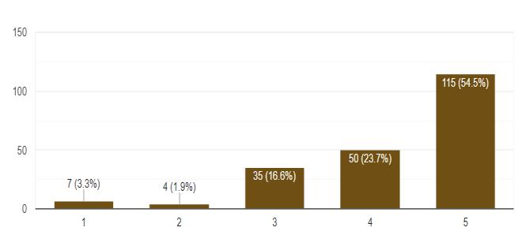

In our research, it was observed that almost 55% of our subjects believe that early education about Body positivity and self-acceptance can be a strong preventive measure against the harmful effects of body shaming on an individual’s mental health. By encouraging an environment of self-acceptance and caressing diverse body types, the young generation can create healthier self-esteem and strength. They start to understand how to tackle various societal pressures and ignore unrealistic beauty standards, thereby reducing the risk of various mental health diseases like anxiety, depression, and eating disorders. Illuminating self-acceptance among teenagers encourages self-acceptance and respect, thus creating a more comprehensive and supportive environment that aims to tackle body shaming challenges with great strength and dignity.
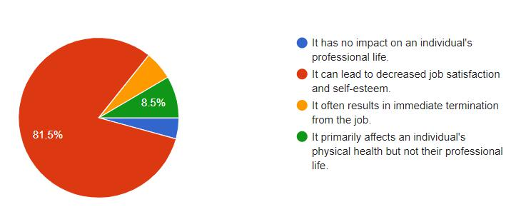

In the workplace, body shaming can lead to many detrimental consequences for any individual. In our research, it was observed that 81.5% of the population believes that Body Shaming an individual in a workplace environment can lead to a major decrease in job satisfaction and self-esteem issues. If an employee is experiencing body
shaming at his workplace, it can directly affect their job performance and overall well-being. Body Shaming can also lead to a toxic workplace environment which can lead to discrimination and disputes. Body Shaming in a workplace environment not only can affect an individual but can also impact team dynamics and organizational culture.

Social Media plays a very major role in sustaining body shaming by promoting various types of unrealistic beauty standards, fostering cyberbullying, and creating a false idea for an “ideal body”. These types of unfeasible beauty standards can negatively impact teenagers, and can ultimately lead to depression, low self-esteem, and anxiety. Moreover, it lays the groundwork for creating a sense of hate, and trolling, which can hurt the sentiments of an individual. To tackle these issues, many movements are being carried out that promote body positivity and understanding that every person is unique and special in their way.
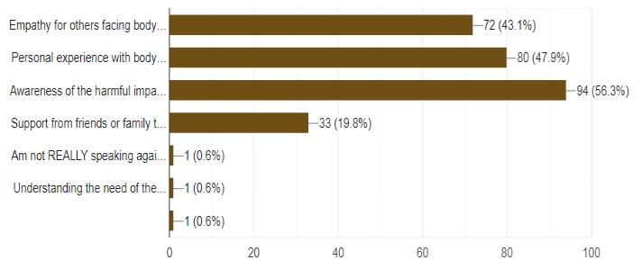

Speaking up against body shaming is significant to promote awareness, empathy, and the mental well-being of an individual. In our research, it was observed that:

- 56.3% of the total population started speaking against body shaming after learning about the harmful effects it has on an individual.

- 47.9% of the total population spoke against Body Shaming because of their personal experiences.

- 43.1% of the total population decided to speak against Body Shaming because of empathy for others who are experiencing body shaming in their life.

- 19.8% decided to speak against Body Shaming after getting support from their friends and family.

It is important to encourage positive dialogue, provide assets, and cultivate a more inclusive, accepting society. It is important to invigorate body positivity and tackle the harmful consequences of body shaming, which can ultimately have a detrimental effect on an individual’s mental health and self-worth.

IV. RESEARCH METHODOLOGY

Participants: Our study comprises 211 candidates which comprise 112 males, 98 females, and 1 non-binary.
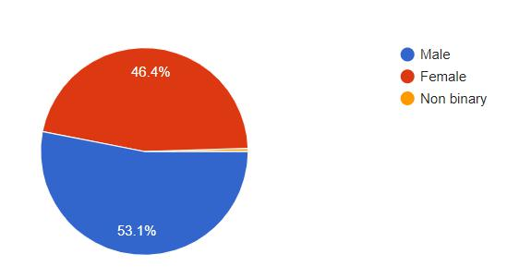

The age index ranges from 15 to 30 years of age where the Mean age=22.6.
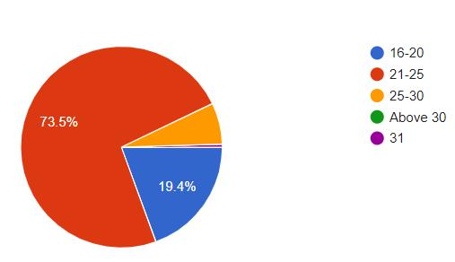

Our study focuses on the youth where almost 58.8% are students and 41.2% are non-students.
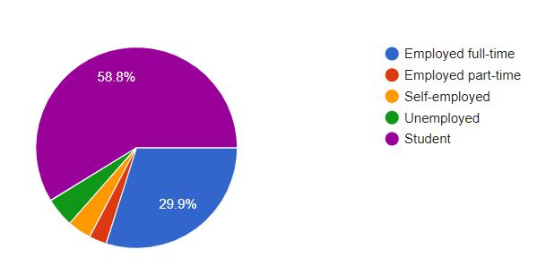

This survey form aims to gather the honest thoughts of individuals from various age groups and how Body Shaming has impacted their lives.

This form focuses on the questions that assess the subjects based on how a person would express their thoughts in various types of scenarios where their emotional intelligence will be tested. Therefore, thorough validity and trustworthiness were kept in mind while doing this survey. Moreover, this survey form was created using Google Forms which comprises six sections and every section focuses on a particular criterion. Data was collected with the help of the Snowball Sampling Technique. After the complete data collection, the analysis was done accordingly Snowball Sampling Technique- Snowball sampling is a non-probabilistic sampling technique used in social research, particularly when it’s difficult to create a complete list of the population being studied.

In Snowball sampling, an initial participant, often called a “seed”, is selected. This seed participant provides referrals to other potential participants.

The process continues, with each new participant referring others. This technique is useful in situations where the population is hard to reach or when no comprehensive sampling frame exists.[3]

The questionnaire was distributed using various types of social media applications like Gmail, Instagram, Twitter, and WhatsApp to students in various universities and many working professionals. Since the survey form was created online, it was easily accessible for everyone and emphasis was put on everyone to share the form as much as possible. Statistics and visualizations were created with the help of PowerBi and Google Forms. The data obtained was clean and raw, therefore it was later analyzed to gather various insights and tables. The analyzed data were discussed by relating it to the research objectives and past studies. Participants were assured of their confidentiality.[2]

All the studies that we carried out in this paper were experimental and were regulated to improve the accuracy of recent and actual research in the field of Body and Fat Shaming.

A. Pre-testing of the questionnaire

This designed survey form was pre-evaluated on 10% of the total population that we were able to collect.

The designed questionnaire was pretested on 10% of the total sample. Relevant modifications were made to the schedule to overcome the difficulties faced during pre-testing.

- EVALUATION

This survey form aims at understanding the mindset and
attitudes they hold for their body. The survey form contains
35 items and the subject is given full liberty to choose their
answers honestly and correctly for accurate analysis.
This survey form focuses on analyzing different levels of
optimism and negativity of a particular person concerning

body or fat shaming and how it has impacted their lives.

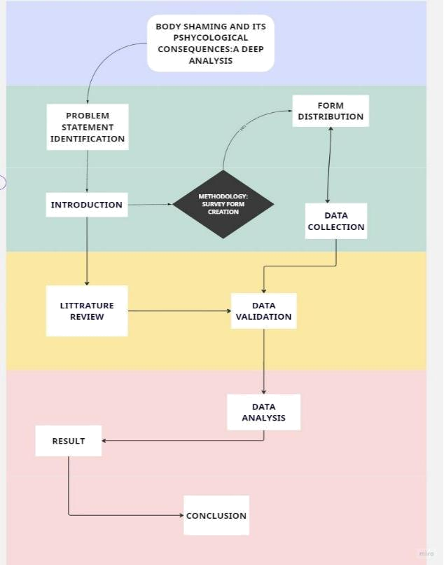

VI. ACKNOWLEDGMENT

We would like to express our heartfelt gratitude to our mentor Dr.Yogesh Pal , Assistant Professor SCSET ,Bennett University ,India who has guided us throughout
our study for this research paper. His guidance has helped us draw insights and inferences from our study. We also want to give special thanks to all the participants who participated in our research and contributed their precious time without whom it would not have been possible for us to complete our research within the required time frame.

We would also like to express our special thanks to our fellow members who have put in their efforts to guide us through their suggestions for improvement in our study. Finally, we want to extend our gratitude and appreciation to our faculty for their patience and encouragement during the research paper which inclined the development of this

research paper. | [1]
VII. CONCLUSION

This paper has argued that body shaming as a severe issue has a serious impact on several perspectives. This paper studied three types of impacts: the impact of body shaming on depression and anxiety; and the impact of body shaming on self-harm. The problem should be raised and taken seriously since it is harmful to both the physical health and mental health of the people of society.

Our research paper aims to analyze the correlation between emotional eloquence, body image, body positivity, and familiarization with life among the young generation of this country.

Body shaming is considered the behavior of hurting or taunting people according to their physical appearance. Due to this, all genders are affected by it both physically and psychologically. Body shaming romanticizes typical and false beauty standards and it has transformed the “perfect body type” in our culture for decades. Additionally, mental diseases, including eating disorders, anxiety, and depression caused by body shaming among school-going adolescents and youth in our society should be a focus in the future.

In the end, we can say that after giving full attention and dedication to the topic, it is important to understand that the current study’s generality was much more streamlined than various global reports. Moreover, we believe that more rigorous studies will be conducted on body shaming and appearance-based harassment to tackle this issue.

VIII. REFERENCES

- R. B. V, A. P, and A. SR, “Psychological Effects of Body Shaming in Adolescence,” Int J Res Appl Sci Eng Technol, vol. 10, no. 11, pp. 277–
279, Nov. 2022, doi: 10.22214/ijraset.2022.47314.

- C. N. Zulkifli, N. A. Ab. Latif, and M. P. Idris, “Body Shaming among University Students: Awareness and Implications on the Body Image,”

International Journal of Academic Research in Business and Social Sciences, vol. 13, no. 2, Feb. 2023, doi: 10.6007/ijarbss/v13-i2/16359.

- M. S. Saxena, M. A. Mathur, and M. S. Jain, “BODY SHAMING,

EMOTIONAL EXPRESSIVITY, AND LIFE ORIENTATION AMONG
YOUNG ADULTS,” 2020. [Online]. Available: www.jetir.org
- “Bullying or fat shaming? The risk factors of Body Dysmorphic

Disorder (BDD) in teenage girls,” Journal of Advanced Research in Social

Sciences and Humanities, vol. 4, no. 1, Feb. 2019, doi: 10.26500/jarssh-04-2019-0103.

- M. Saifudin, S. Sholikah, and E. W. Apreliani, “A R T I C L E I N F O,” 2022. [Online]. Available: www.e-journal.unair.ac.id/JoViN/

